Table of contents 1
3* vessels
- MS“Zosima Shashkov” 2
- MS“Georgy Chicherin” 4
4* vessels
- MS“Nikolay Chernishevsky” 6
- MS“Konstantin Fedin” 9
- MS“Nizhny Novgorod” 11
- MS“Kronshtadt” 14
Deck plan. Type 301 (MS “Nizhny Novgorod”) 16
Deck plan. Type 301 (MS “Nikolay Chernishevsky”) 17
Deck plan. Type 301 (MS “Konstantin Fedin”) 18
Deck plan. Type 301 (MS “Kronshtadt”) 19
Deck plan. Type 302
(MS “Zosima Shashkov” , MS“Georgy Chicherin”) 20
Rates for 3* ships 21
Terms and Conditions for 3* ships 21
Rates for 4* ships 22
Terms and Conditions for 4* ships 23

Motorship «Zosima Shashkov» is a comfortable four-deck vessel (type 302). Built in Germany in 1986 and refurbished in 2013, the motorship is equipped with modern of 25,5 km per hour (around 17MpH).
- Length –129 m
- Width –16,7 m
- Draught –2,9 m
- Passenger capacity –280 pax
(quad cabins for double accommodation)

Vassel features: Accomodation:
- Restaurant  - Bar- restaurant  - 2 Bars  - Solarium  - Sauna  - Medical room  - Souvenir store  - Conference hall/bar  - Ironing room | 2 suites  10 singles  128 twins  14 quads  (2 upper and 2 lower berths) | All cabins are equipped with private facilities, wardrobe, radio, refrigerator and air conditioning. There is a large scenic window in each cabin (except lower deck).

Itinerary:

Dates | № of days and nights | Direction | Season
07 May – 18 May | 12 days/11 nights | Moscow-Saint Petersburg | A
18 May – 28 May | 11 days/10 nights | Saint Petersburg-Moscow | B
28 May – 08 June | 12 days/11 nights | Moscow-Saint Petersburg | C
08 June – 18 June | 11 days/10 nights | Saint Petersburg-Moscow | C
18 June – 29 June | 12 days/11 nights | Moscow-Saint Petersburg | D
29 June – 09 July | 11 days/10 nights | Saint Petersburg-Moscow | D
09 July – 20 July | 12 days/11 nights | Moscow-Saint Petersburg | D
20 July – 30 July | 11 days/10 nights | Saint Petersburg-Moscow | C
30 July – 10 Aug | 12 days/11 nights | Moscow-Saint Petersburg | C
10 Aug – 20 Aug | 11 days/10 nights | Saint Petersburg-Moscow | C
20 Aug – 31 Aug | 12 days/11 nights | Moscow-Saint Petersburg | C
31 Aug – 10 Sept | 11 days/10 nights | Saint Petersburg-Moscow | C
10 Sept – 21 Sept | 12 days/11 nights | Moscow-Saint Petersburg | C
21 Sept – 01 Oct | 11 days/10 nights | Saint Petersburg-Moscow | A
01 Oct – 12 Oct | 12 days/11 nights | Moscow-Saint Petersburg | A

Included excursion programme for MS“Zosima Shashkov ”
Moscow– St. Petersburg (12 days/11 nights)

Transfer from the airport, bus city tour, Kremlin with a visit to 1 Cathedral, 1 lunch in the city
1 - 3 Moscow
Excursion programme
Day Port of call
Walking city tour with a visit to the Kremlin territory, The Church of St. Dmitry on the Blood, The Transfiguration Cathedral

5 Yaroslavl
4 Uglich
Bus city tour, local market (free time), The Church of St. Elijah the Prophet (outside), the Church of St. Nicholas the Wonderworker (inside), interactive tour of the former Governor’s House (Art Gallery)
- Goritsy Monastery of St. Cyril on the White Lake, museum of icons
- Kizhi Open-air museum of wooden architecture
- Mandrogui Free time, kebab (shashlik) ashore
Bus city tour with a visit to Peter and Paul fortress, Hermitage museum, Peterhof (lower park), transfer to the airport
9 -12 St. Petersburg

St. Petersburg– Moscow (11 days/10 nights)

Transfer from the airport, bus city tour with a visit to Peter and Paul fortress, Hermit- age museum
1 - 3 St. Petersburg
Excursion programme
Day Port of call
- Mandrogui Free time, kebab (shashlik) ashore
- Kizhi Open-air museum of wooden architecture
- Goritsy Monastery of St. Cyril on the White Lake, museum of icons
Bus city tour, local market (free time), The Church of St. Elijah the Prophet (outside), the Church of St. Nicholas the Wonderworker (inside), interactive tour of the former Governor’s House (Art Gallery)

7 Yaroslavl
Walking city tour with a visit to the Kremlin territory, The Church of St. Dmitry on
8 Uglich
the Blood, The Transfiguration Cathedral
9 -11 Moscow Bus city tour, Kremlin with a visit to 1 Cathedral, transfer to the airport

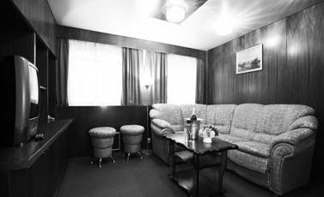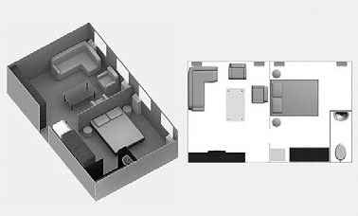
SUIT
Suite cabin
E

Two-room cabin with separate bedroom and lounge area, around 30 square meters, equipped with private facilities, heating and ventilation sys- tem, 220 volt sockets, radio, 4 large opening scenic windows. Lounge area is furnished in a stylish way
with a roomy wardrobe, occasional table, cush- ioned furniture, TV/video, refrigerator. Bedroom is furnished with a king-size bed, wardrobe and console-mirror. Suite can accommodate up to 3 people. Extra bed type - folding-bed.

Motorship «Georgy Chicherin» is a comfortable four-deck vessel (type 302). Built in Germany in 1984 and refurbished in 2012, the motorship is equipped with modern navigational facilities and exceeds the speed of 26 km per hour (around 17MpH).
- Length –129 m
- Width – 16,7 m
- Draught – 2,9 m
- Passenger capacity – 280 pax
(quad cabins for double accommodation)

Vessel features: Accommodation:

- Restaurant
- Bar- restaurant
- 2 Bars
- Solarium
- Sauna
2 suites
10 singles
128 twins
14 quads
(2 upper and 2 lower berths)

- Medical room
- Souvenir store
- Conference hall
- Ironing room
All cabins are equipped with private facilities, wardrobe, radio, refrigerator and air conditioning. There is a large scenic window in each cabin (except lower deck).

Itinerary:

Dates
№ of days and nights
Direction
Season
11 May – 21 May 11 days/10 nights Saint Petersburg-Moscow А 21 May – 01 June 12 days/11 nights Moscow-Saint Petersburg B 01 June – 11 June 11 days/10 nights Saint Petersburg-Moscow B 11 June – 22 June 12 days/11 nights Moscow-Saint Petersburg D 22 June – 02 July 11 days/10 nights Saint Petersburg-Moscow D 02 July – 13 July 12 days/11 nights Moscow-Saint Petersburg D 13 July – 23 July 11 days/10 nights Saint Petersburg-Moscow C 23 July – 03 Aug 12 days/11 nights Moscow-Saint Petersburg C 03 Aug – 13 Aug 11 days/10 nights Saint Petersburg-Moscow C 13 Aug – 24 Aug 12 days/11 nights Moscow-Saint Petersburg C 24 Aug – 03 Sept 11 days/10 nights Saint Petersburg-Moscow B 03 Sept – 14 Sept 12 days/11 nights Moscow-Saint Petersburg C 1
А
Moscow-Saint Petersburg
12 days/11 nights
24 Sept – 05 Oct

Included excursion programme for MS“Georgy Chicherin”

Moscow– St. Petersburg (12 days/11 nights)

Transfer from the airport, bus city tour, Kremlin with a visit to 1 Cathedral, 1 lunch in the city
1 - 3 Moscow
Excursion programme
Day Port of call
Walking city tour with a visit to the Kremlin territory, The Church of St. Dmitry on the Blood, The Transfiguration Cathedral

5 Yaroslavl
4 Uglich
Bus city tour, local market (free time), The Church of St. Elijah the Prophet (outside), the Church of St. Nicholas the Wonderworker (inside), interactive tour of the former Governor’s House (Art Gallery)
- Goritsy Monastery of St. Cyril on the White Lake, museum of icons
- Kizhi Open-air museum of wooden architecture
- Mandrogui Free time, kebab (shashlik) ashore
Bus city tour with a visit to Peter and Paul fortress, Hermitage museum, Peterhof (lower park), transfer to the airport
9 -12 St. Petersburg

St. Petersburg– Moscow (11 days/10 nights)
Excursion programme
Day Port of call
Transfer from the airport, bus city tour with a visit to Peter and Paul fortress, Hermit-
age museum
1 - 3 St. Petersburg
- Mandrogui Free time, kebab (shashlik) ashore
- Kizhi Open-air museum of wooden architecture
- Goritsy Monastery of St. Cyril on the White Lake, museum of icons
Bus city tour, local market (free time), The Church of St. Elijah the Prophet (outside), the Church of St. Nicholas the Wonderworker (inside), interactive tour of the former Governor’s House (Art Gallery)

7 Yaroslavl
Walking city tour with a visit to the Kremlin territory, The Church of St. Dmitry on
8 Uglich
the Blood, The Transfiguration Cathedral
9 -11 Moscow Bus city tour, Kremlin with a visit to 1 Cathedral, transfer to the airport

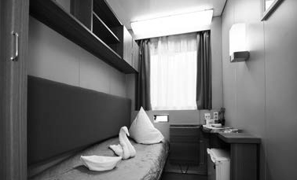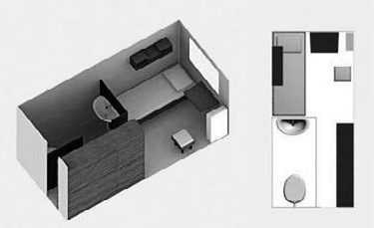
SINGL
Single cabin
E

One-bed outside cabin with a large opening scenic window, around 8 square meters, equipped with private facilities, heating and ventilation
system, refrigerator, wardrobe, 220 volt socket, radio. Cabin is furnished in a practical style.

Motorship «Nikolay Chernishevsky» is a comfortable four-deck vessel (type 301). Built in Germany in 1981 and refurbished in 2018, the motorship is equipped with modern navigational facilities and exceeds the speed of 26 km per hour (around 17 MpH).
- Length –125 m
- Width –16,7 m
- Draught – 2,9 m
- Passenger capacity – 218 pax (triple cabins for double accommodation)

Vessel features: Accommodation:

- 2 Restaurants
- 2 Bars
- Solarium
- Sauna
- Medical room
2 suites
2 junior suites
46 deluxes
18 singles
40 twins
10 triples (2 lower and 1 upper bed)

- Souvenir store
- Conference hall/bar
- Ironing room
All cabins are equipped with private facilities, wardrobe, radio, TV, safe, refrigerator, air conditioning. There is a large scenic window in each cabin (except lower deck).

Itinerary:

Dates | № of days and nights | Direction | Season
11 May – 21 May | 11 days/10 nights | Saint Petersburg-Moscow | А
21 May – 01 June | 12 days/11 nights | Moscow-Saint Petersburg | B
01 June – 11 June | 11 days/10 nights | Saint Petersburg-Moscow | B
11 June – 22 June | 12 days/11 nights | Moscow-Saint Petersburg | D
22 June – 02 July | 11 days/10 nights | Saint Petersburg-Moscow | D
02 July – 13 July | 12 days/11 nights | Moscow-Saint Petersburg | D
13 July – 23 July | 11 days/10 nights | Saint Petersburg-Moscow | C
23 July – 03 Aug | 12 days/11 nights | Moscow-Saint Petersburg | C
03 Aug – 13 Aug | 11 days/10 nights | Saint Petersburg-Moscow | C
13 Aug – 24 Aug | 12 days/11 nights | Moscow-Saint Petersburg | C
24 Aug – 03 Sept | 11 days/10 nights | Saint Petersburg-Moscow | B
03 Sept – 14 Sept | 12 days/11 nights | Moscow-Saint Petersburg | C
14 Sept – 24 Sept | 11 days/10 nights | Saint Petersburg-Moscow | B
24 Sept – 07 Oct | 14 days/13 nights | Moscow-Astrakhan | А
07 Oct – 20 Oct | 14 days/13 nights | Astrakhan-Moscow | А

Included excursion programme for MS“Nikolay Chernishevsky”
Moscow– St. Petersburg (12 days/11 nights)

Transfer from the airport, bus city tour, Kremlin with a visit to 1 Cathedral, 1 lunch in the city
1 - 3 Moscow
Excursion programme
Day Port of call
Walking city tour with a visit to the Kremlin territory, The Church of St. Dmitry on the Blood, The Transfiguration Cathedral

5 Yaroslavl
4 Uglich
Bus city tour, local market (free time), The Church of St. Elijah the Prophet (outside), the Church of St. Nicholas the Wonderworker (inside), interactive tour of the former Governor’s House (Art Gallery)
- Goritsy Monastery of St. Cyril on the White Lake, museum of icons
- Kizhi Open-air museum of wooden architecture
- Mandrogui Free time, kebab (shashlik) ashore
Bus city tour with a visit to Peter and Paul fortress, Hermitage museum, Peterhof (lower park), transfer to the airport
9 -12 St. Petersburg

St. Petersburg– Moscow (11 days/10 nights)

Transfer from the airport, bus city tour with a visit to Peter and Paul fortress, Hermit- age museum
1 - 3 St. Petersburg
Excursion programme
Day Port of call
- Mandrogui Free time, kebab (shashlik) ashore
- Kizhi Open-air museum of wooden architecture
- Goritsy Monastery of St. Cyril on the White Lake, museum of icons
Bus city tour, local market (free time), The Church of St. Elijah the Prophet (outside), the Church of St. Nicholas the Wonderworker (inside), interactive tour of the former Governor’s House (Art Gallery)

7 Yaroslavl
Walking city tour with a visit to the Kremlin territory, The Church of St. Dmitry on
8 Uglich
the Blood, The Transfiguration Cathedral
9 -11 Moscow Bus city tour, Kremlin with a visit to 1 Cathedral, transfer to the airport
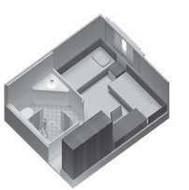
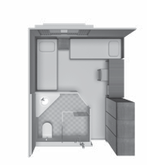
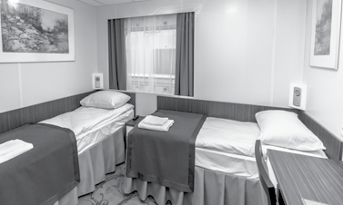
DELUXE MAIN DECK
Deluxe Main Deck

Spacious twin cabin with a large opening scenic window, heating and ventilation system, wardrobe, vanity table, 220 volt socket, radio, TV, safe. Cabin is equipped with new furniture, lighting and decorat-
ed in modern style. There is a refurbished bathroom of increased size (shower is situated separately in the corner).

Included excursion programme for MS “Nikolay Chernishevsky”
Moscow– Astrakhan (14 days/13 nights)
Day Port of call Excursion programme
1 - 3 | Moscow | Transfer from the airport, bus city tour, Kremlin with a visit to 1 Cathedral,  The State Tretyakov Gallery
4 | Uglich | Walking city tour with a visit to the Kremlin territory, The Church of St. Dmitry on the Blood, The Transfiguration Cathedral
5 | Yaroslavl | Bus city tour, local market (free time), The Church of St. Nicholas the Wonder- worker (inside), The Church of St. Elijah the Prophet (outside), interactive tour of
 |  | the former Governor’s House (Art Gallery)
5 | Kostroma | Bus city tour, The Ipatiev Monastery, The Trinity Cathedral
6 | Nizhny Novgorod | Bus city tour, Kremlin grounds
7 | Cheboksary | Bus city tour
8 | Kazan | Bus city tour, Kremlin grounds
9 | Samara | Bus city tour, Art Gallery
10 | Saratov | Bus city tour
11 | Volgograd | Bus city tour, Mamayev Kurgan
12 | Day on board | Entertainment programme
13 - 14 | Astrakhan | Bus city tour, Kremlin grounds, transfer to the airport
Astrakhan – Moscow (14 days/13 nights)
Day | Port of call | Excursion programme
1-2 | Astrakhan | Transfer from the airport, bus city tour, Kremlin grounds
3 | Day on board | Entertainment programme
4 | Volgograd | Bus city tour, Mamayev Kurgan
5 | Saratov | Bus city tour
6 | Samara | Bus city tour, Art Gallery
7 | Kazan | Bus city tour, Kremlin grounds
8 | Cheboksary | Bus city tour
9 | Nizhny Novgorod | Bus city tour, Kremlin grounds
10 | Kostroma | Bus city tour, The Ipatiev Monastery, The Trinity Cathedral
10 | Yaroslavl | Bus city tour, local market (free time), The Church of St. Nicholas the Wonder- worker (inside), The Church of St. Elijah the Prophet (outside), interactive tour of
 |  | the former Governor’s House (Art Gallery)
11 Uglich Walking city tour with a visit to the Kremlin territory, The Church of St. Dmitry on the Blood, The Transfiguration Cathedral
Bus city tour, Kremlin with a visit to 1 Cathedral, The State Tretyakov gallery, transfer to the airport
12-14 Moscow

Motorship «Konstantin Fedin» is a comfortable four-deck vessel (type 301). Built in Germany in 1980 and refurbished in 2018, the motorship is equipped with modern navigational facilities and exceeds the speed of 26 km per hour (around 17MpH).
- Length –125 m
- Width – 16,7 m
- Draught – 2,7 m
- Passenger capacity – 212 pax
(triple cabins for double accommodation)

Vessel features: Accommodation:

- 2 Restaurants
- 2 Bars
- Solarium
- Sauna
6 suites
40 deluxes
20 singles
40 twins
10 triples (2 lower and 1 upper bed)

- Medical room
- Souvenir store
- Conference hall/bar
- Ironing room
All cabins are equipped with private facilities, wardrobe, radio, TV, safe, refrigerator and air conditioning. There is a large scenic window in each cabin (except lower deck).

Itinerary:

Dates | № of days and nights | Direction | Season
07 May – 18 May | 12 days/11 nights | Moscow-Saint Petersburg | A
18 May – 28 May | 11 days/10 nights | Saint Petersburg-Moscow | B
28 May – 08 June | 12 days/11 nights | Moscow-Saint Petersburg | C
08 June – 18 June | 11 days/10 nights | Saint Petersburg-Moscow | C
18 June – 29 June | 12 days/11 nights | Moscow-Saint Petersburg | D
29 June – 09 July | 11 days/10 nights | Saint Petersburg-Moscow | D
09 July – 20 July | 12 days/11 nights | Moscow-Saint Petersburg | D
20 July – 30 July | 11 days/10 nights | Saint Petersburg-Moscow | C
30 July – 10 Aug | 12 days/11 nights | Moscow-Saint Petersburg | C
10 Aug – 20 Aug | 11 days/10 nights | Saint Petersburg-Moscow | C
20 Aug – 31 Aug | 12 days/11 nights | Moscow-Saint Petersburg | C
31 Aug – 10 Sept | 11 days/10 nights | Saint Petersburg-Moscow | C
10 Sept – 21 Sept | 12 days/11 nights | Moscow-Saint Petersburg | B
21 Sept – 01 Oct | 11 days/10 nights | Saint Petersburg-Moscow | A
01 Oct – 12 Oct | 12 days/11 nights | Moscow-Saint Petersburg | А

Included excursion programme for MS“Konstantin Fedin”
Moscow– St. Petersburg (12 days/11 nights)

Transfer from the airport, bus city tour, Kremlin with a visit to 1 Cathedral, 1 lunch in the city
1 - 3 Moscow
Excursion programme
Day Port of call
Walking city tour with a visit to the Kremlin territory, The Church of St. Dmitry on the Blood, The Transfiguration Cathedral

5 Yaroslavl
4 Uglich
Bus city tour, local market (free time), The Church of St. Elijah the Prophet (outside), the Church of St. Nicholas the Wonderworker (inside), interactive tour of the former Governor’s House (Art Gallery)
- Goritsy Monastery of St. Cyril on the White Lake, museum of icons
- Kizhi Open-air museum of wooden architecture
- Mandrogui Free time, kebab (shashlik) ashore
Bus city tour with a visit to Peter and Paul fortress, Hermitage museum, Peterhof (lower park), transfer to the airport
9 -12 St. Petersburg

St. Petersburg– Moscow (11 days/10 nights)
Excursion programme
Day Port of call
Transfer from the airport, bus city tour with a visit to Peter and Paul fortress, Hermit-
1 - 3 St. Petersburg
age museum
- Mandrogui Free time, kebab (shashlik) ashore
- Kizhi Open-air museum of wooden architecture
- Goritsy Monastery of St. Cyril on the White Lake, museum of icons
Bus city tour, local market (free time), The Church of St. Elijah the Prophet (outside), the Church of St. Nicholas the Wonderworker (inside), interactive tour of the former Governor’s House (Art Gallery)

7 Yaroslavl
Walking city tour with a visit to the Kremlin territory, The Church of St. Dmitry on
8 Uglich
the Blood, The Transfiguration Cathedral
9 -11 Moscow Bus city tour, Kremlin with a visit to 1 Cathedral, transfer to the airport

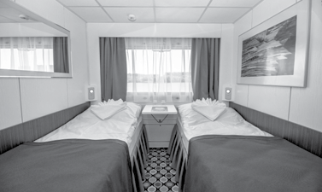
TWIN
Twin cabin

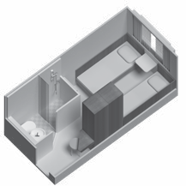
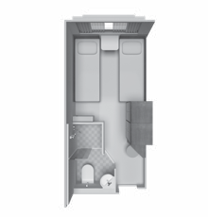
Two-bed outside single-staged cabin with a large opening scenic window, equipped with private facilities, heating and ventilation system,TV, safe, re-
frigerator, wardrobe, 220 volt socket, radio. Cabin is furnished in a practical style. It can be used for single accommodation as one of the beds is foldaway.

Motorship «Nizhny Novgorod» is a comfortable four-deck vessel (type 301). Built in Germany in 1977, refurbished in 2019,
the motorship is equipped with modern navigational facilities and exceeds the speed of 26 km per hour (around 17MpH)..
- Length – 125 m
- Width – 16,7 m
- Draught – 2,8 m
- Passenger capacity – 216 pax
(triple cabins for double accommodation)

Vessel features: Accommodation:

- 2 Restaurants
- Conference hall/bar
- Panorama bar
- Small bar
- Sauna
6 suites
40 deluxes
8 singles
48 twins
10 triples (2 lower and 1 upper bed)

- Souvenir store
- Solarium
- Medical room
All cabins are outside with large (except lower deck) scenic win- dows, equipped with private facilities, air-conditioning, ward- robes, TV, safe, refrigerators and 220 volt sockets.

Itinerary:

Dates
№ of days and nights
Direction
Season
05 May – 16 May 12 days/11 nights Moscow-Saint Petersburg A 16 May – 26 May 11 days/10 nights Saint Petersburg-Moscow B 26 May – 06 June 12 days/11 nights Moscow-Saint Petersburg C 06 June – 16 June 11 days/10 nights Saint Petersburg-Moscow C 16 June – 27 June 12 days/11 nights Moscow-Saint Petersburg D 27 June – 07 July 11 days/10 nights Saint Petersburg-Moscow D 07 July – 18 July 12 days/11 nights Moscow-Saint Petersburg D 18 July – 28 July 11 days/10 nights Saint Petersburg-Moscow C 28 July – 08 Aug 12 days/11 nights Moscow-Saint Petersburg D 08 Aug – 18 Aug 11 days/10 nights Saint Petersburg-Moscow C 18 Aug – 29 Aug 12 days/11 nights Moscow-Saint Petersburg C 29 Aug – 08 Sept 11 days/10 nights Saint Petersburg-Moscow B 08 Sept – 21 Sept 14 days/13 nights Moscow-Astrakhan B
A
Astrakhan-Moscow
14 days/13 nights
21 Sept – 04 Oct

Included excursion programme for MS“Nizhny Novgorod”
Moscow– St. Petersburg (12 days/11 nights)

Transfer from the airport, bus city tour, Kremlin with a visit to 1 Cathedral, 1 lunch in the city
1 - 3 Moscow
Excursion programme
Day Port of call
Walking city tour with a visit to the Kremlin territory, The Church of St. Dmitry on the Blood, The Transfiguration Cathedral

5 Yaroslavl
4 Uglich
Bus city tour, local market (free time), The Church of St. Elijah the Prophet (outside), the Church of St. Nicholas the Wonderworker (inside), interactive tour of the former Governor’s House (Art Gallery)
- Goritsy Monastery of St. Cyril on the White Lake, museum of icons
- Kizhi Open-air museum of wooden architecture
- Mandrogui Free time, kebab (shashlik) ashore
Bus city tour with a visit to Peter and Paul fortress, Hermitage museum, Peterhof (lower park), transfer to the airport
9 -12 St. Petersburg

St. Petersburg– Moscow (11 days/10 nights)

Transfer from the airport, bus city tour with a visit to Peter and Paul fortress, Hermit- age museum
1 - 3 St. Petersburg
Excursion programme
Day Port of call
- Mandrogui Free time, kebab (shashlik) ashore
- Kizhi Open-air museum of wooden architecture
- Goritsy Monastery of St. Cyril on the White Lake, museum of icons
Bus city tour, local market (free time), The Church of St. Elijah the Prophet (outside), the Church of St. Nicholas the Wonderworker (inside), interactive tour of the former Governor’s House (Art Gallery)

7 Yaroslavl
Walking city tour with a visit to the Kremlin territory, The Church of St. Dmitry on
8 Uglich
the Blood, The Transfiguration Cathedral
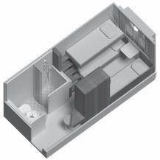
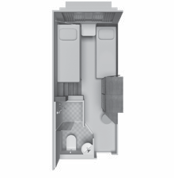
9 -11 Moscow Bus city tour, Kremlin with a visit to 1 Cathedral, transfer to the airport
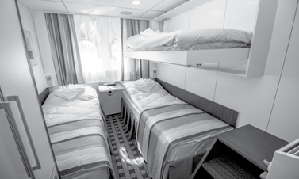
TRIPLE
Triple cabin

Three-bed two-staged cabin with two non-opening portholes, equipped with heating and ventilation system, wardrobe, 220 volt socket, refrigerator, TV, safe, radio. Cabin is equipped with new furniture and
lighting; decorated in modern style. Refurbished bathroom of increased size (shower is situated sepa- rately in a corner). Can be used for double accommo- dation as one of the beds is a foldaway bed)

Included excursion programme for MS“Nizhny Novgorod”
Moscow– Astrakhan (14 days/13 nights)
Day Port of call Excursion programme
Transfer from the airport, bus city tour, Kremlin with a visit to 1 Cathedral, The State Tretyakov Gallery
4 | Uglich | Walking city tour with a visit to the Kremlin territory, The Church of St. Dmitry on the Blood, The Transfiguration Cathedral
5 | Yaroslavl | Bus city tour, local market (free time), The Church of St. Nicholas the Wonder- worker (inside), The Church of St. Elijah the Prophet (outside), interactive tour of
 |  | the former Governor’s House (Art Gallery)
5 | Kostroma | Bus city tour, The Ipatiev Monastery, The Trinity Cathedral
6 | Nizhny Novgorod | Bus city tour, Kremlin grounds
7 | Cheboksary | Bus city tour
8 | Kazan | Bus city tour, Kremlin grounds
9 | Samara | Bus city tour, Art Gallery
10 | Saratov | Bus city tour
11 | Volgograd | Bus city tour, Mamayev Kurgan
12 | Day on board | Entertainment programme
13 - 14 | Astrakhan | Bus city tour, Kremlin grounds, transfer to the airport

Astrakhan – Moscow (14 days/13 nights)
1 - 3 Moscow

Day | Port of call | Excursion programme
1-2 | Astrakhan | Transfer from the airport, bus city tour, Kremlin grounds
3 | Day on board | Entertainment programme
4 | Volgograd | Bus city tour, Mamayev Kurgan
5 | Saratov | Bus city tour
6 | Samara | Bus city tour, Art Gallery
7 | Kazan | Bus city tour, Kremlin grounds
8 | Cheboksary | Bus city tour
9 | Nizhny Novgorod | Bus city tour, Kremlin grounds
10 | Kostroma | Bus city tour, The Ipatiev Monastery, The Trinity Cathedral
10 | Yaroslavl | Bus city tour, local market (free time), The Church of St. Nicholas the Wonder- worker (inside), The Church of St. Elijah the Prophet (outside), interactive tour of
 |  | the former Governor’s House (Art Gallery)
11 Uglich Walking city tour with a visit to the Kremlin territory, The Church of St. Dmitry on the Blood, The Transfiguration Cathedral
Bus city tour, Kremlin with a visit to 1 Cathedral, The State Tretyakov gallery, transfer to the airport
12-14 Moscow

Motorship «Kronshtadt» is a comfortable four-deck vessel (type 301). Built in Germany in 1979 and refurbished in 2018, the motor- ship is equipped with modern navigational facilities and exceeds the speed of 26 km per hour (around 17 MpH).
- Length – 125 m
- Width – 16,7 m
- Draught – 2,75 m
Passenger capacity – 212 pax (triple cabins for double accommodation)

Vessel features: Accommodation:

- 2 Restaurants
- Panorama bar and musical lounge
- Small bar
- Conference hall/bar
6 suites
40 deluxes
20 singles
40 twins
10 triples (2 lower and 1 upper bed)

- Souvenir store
- Solarium
- Ironing room
- Medical room
All cabins are outside with large scenic windows (except lower deck cabins), equipped with private facilities, TV, safe, air-condi- tioning and 220 volt sockets.

Itinerary:

Dates | № of days and nights | Direction | Season
04 May-15 May | 12 days/11 nights | Moscow-Saint Petersburg | A
15 May-25 May | 11 days/10 nights | Saint Petersburg-Moscow | B
25 May-05 June | 12 days/11 nights | Moscow-Saint Petersburg | C
05 June-15 June | 11 days/10 nights | Saint Petersburg-Moscow | C
15 June-26 June | 12 days/11 nights | Moscow-Saint Petersburg | D
26 June-06 July | 11 days/10 nights | Saint Petersburg-Moscow | D
06 July-17 July | 12 days/11 nights | Moscow-Saint Petersburg | D
17 July-27 July | 11 days/10 nights | Saint Petersburg-Moscow | C
27 July-07 Aug | 12 days/11 nights | Moscow-Saint Petersburg | D
07 Aug-17 Aug | 11 days/10 nights | Saint Petersburg-Moscow | C
17 Aug-28 Aug | 12 days/11 nights | Moscow-Saint Petersburg | C
28 Aug-07 Sept | 11 days/10 nights | Saint Petersburg-Moscow | B
07 Sept-18 Sept | 12 days/11 nights | Moscow-Saint Petersburg | C
18 Sept-28 Sept | 11 days/10 nights | Saint-Petersburg-Moscow | A
28 Sept-09 Oct | 12 days/11 nights | Moscow-Saint Petersburg | A

Included excursion programme for MS“Kronshtadt”
Moscow– St. Petersburg (12 days/11 nights)

Transfer from the airport, bus city tour, Kremlin with a visit to 1 Cathedral, 1 lunch in the city
1 - 3 Moscow
Excursion programme
Day Port of call
Walking city tour with a visit to the Kremlin territory, The Church of St. Dmitry on the Blood, The Transfiguration Cathedral

5 Yaroslavl
4 Uglich
Bus city tour, local market (free time), The Church of St. Elijah the Prophet (outside), the Church of St. Nicholas the Wonderworker (inside), interactive tour of the former Governor’s House (Art Gallery)
- Goritsy Monastery of St. Cyril on the White Lake, museum of icons
- Kizhi Open-air museum of wooden architecture
- Mandrogui Free time, kebab (shashlik) ashore
Bus city tour with a visit to Peter and Paul fortress, Hermitage museum, Peterhof (lower park), transfer to the airport
9 -12 St. Petersburg

St. Petersburg– Moscow (11 days/10 nights)
Excursion programme
Day Port of call
Transfer from the airport, bus city tour with a visit to Peter and Paul fortress, Hermit-
1 - 3 St. Petersburg
age museum
- Mandrogui Free time, kebab (shashlik) ashore
- Kizhi Open-air museum of wooden architecture
- Goritsy Monastery of St. Cyril on the White Lake, museum of icons
Bus city tour, local market (free time), The Church of St. Elijah the Prophet (outside), the Church of St. Nicholas the Wonderworker (inside), interactive tour of the former Governor’s House (Art Gallery)

7 Yaroslavl
Walking city tour with a visit to the Kremlin territory, The Church of St. Dmitry on
8 Uglich
the Blood, The Transfiguration Cathedral
9 -11 Moscow Bus city tour, Kremlin with a visit to 1 Cathedral, transfer to the airport

DELUXE BOAT DECK

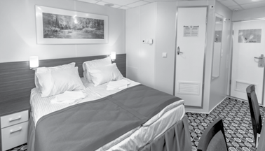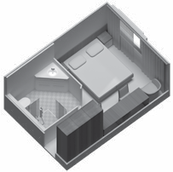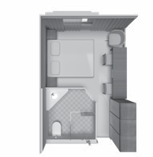
Deluxe boat deck

Spacious double cabin with a large opening scenic window, heating and ventilation system, TV, safe, wardrobe, 220 volt socket, radio. Cabin is equipped with new furniture and lighting and
decorated in modern style. There is a refurbished bathroom of increased size (shower is situated separately in the corner)

16
Type 301 (MS “Nizhny Novgorod”)

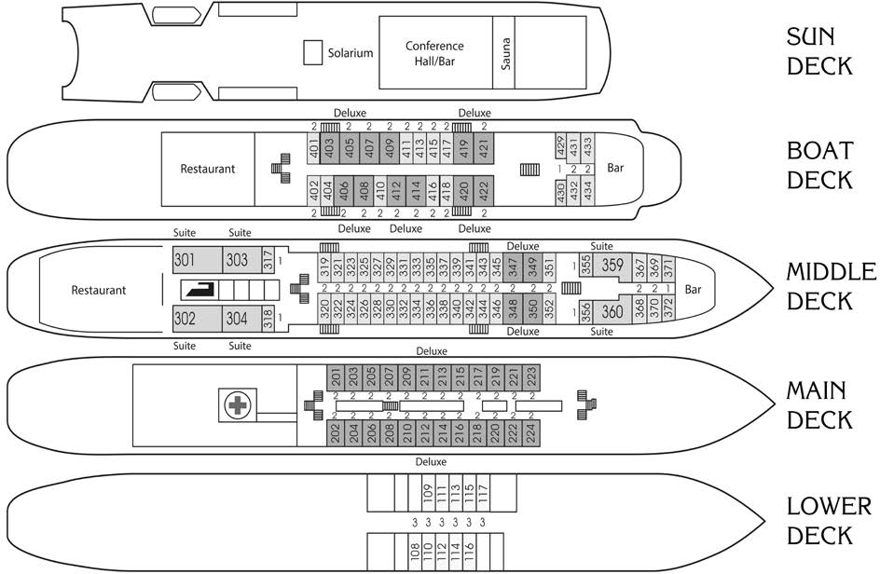

17
Type 301 (MS“Nikolay Chernishevsky”)
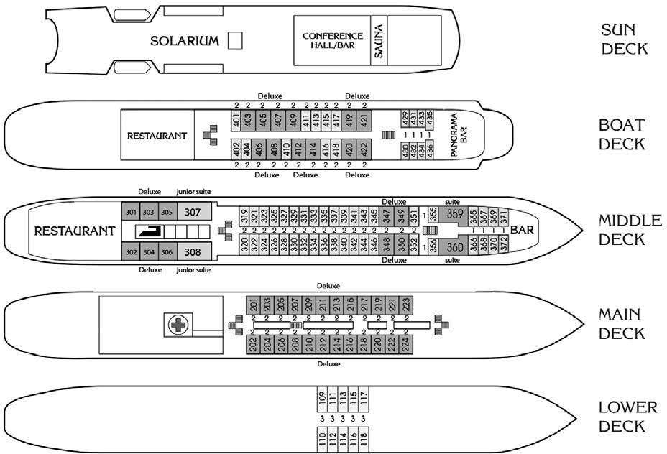

18
Type 301 (MS“Konstantin Fedin”)

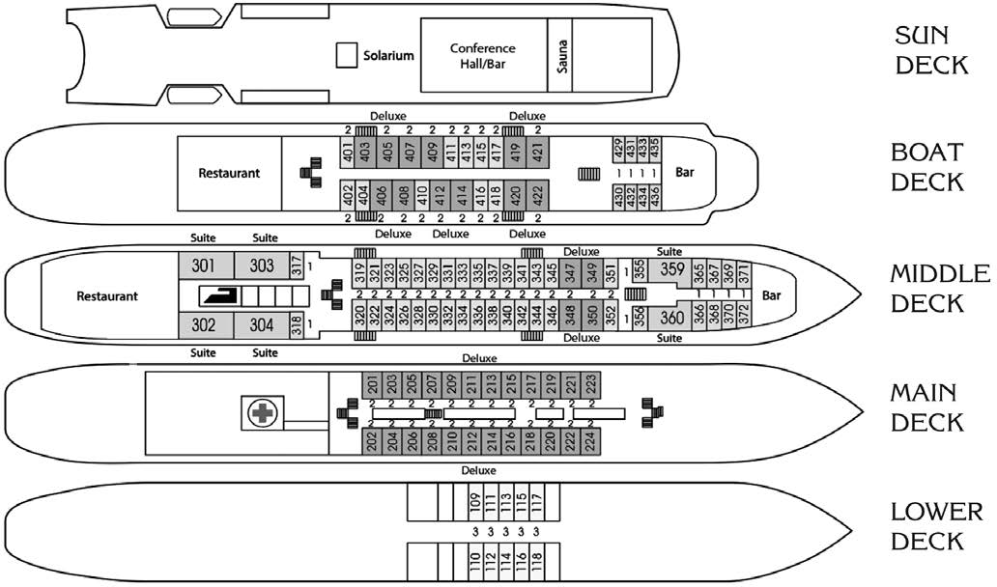

19
Type 301 (MS“Kronshtadt”)
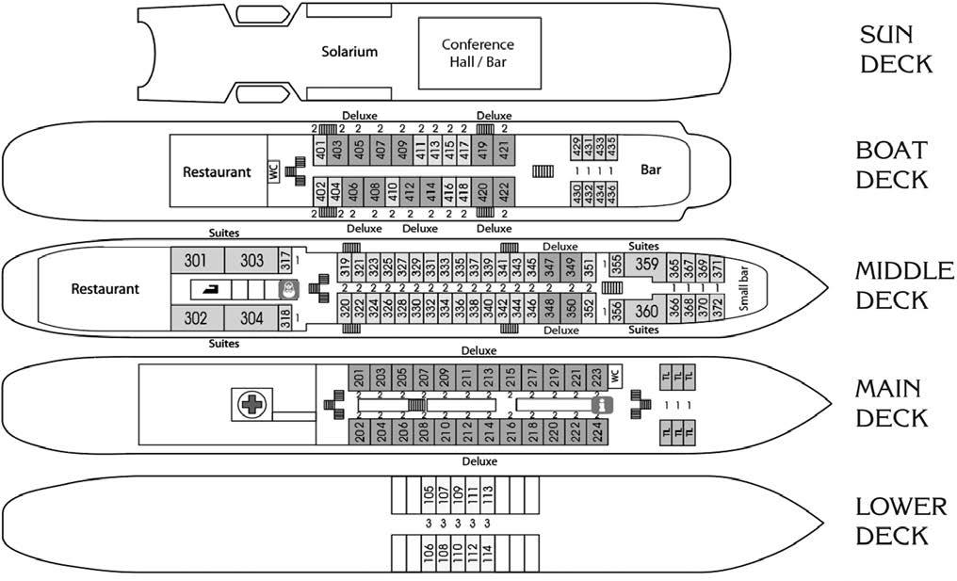

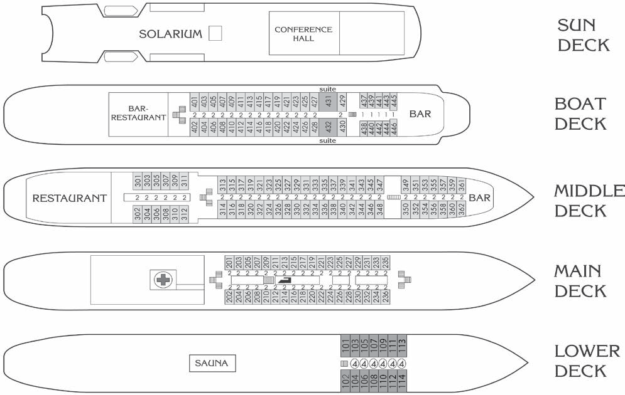
Type 302 (MS“Zosima Shashkov”, MS“Georgy Chicherin”)
20

Rates for 3* vessels

Moscow - St. Petersburg (12 days/11 nights)
Season | Quad for dbl use Lower deck | Twin Main deck | Twin Middle deck | Twin Boat deck | Sngl Boat deck | Suite Boat deck
A | 1290 | 1455 | 1510 | 1565 | 1675 | 1895
B | 1323 | 1510 | 1565 | 1620 | 1730 | 2005
C | 1345 | 1620 | 1675 | 1730 | 1840 | 2170
D | 1400 | 1697 | 1752 | 1807 | 2005 | 2555
St. Petersburg – Moscow (11 days/10 nights)
Season | Quad for dbl use Lower deck | Twin Main deck | Twin Middle deck | Twin Boat deck | Sngl Boat deck | Suite Boat deck
A | 1200 | 1350 | 1400 | 1450 | 1550 | 1750
B | 1230 | 1400 | 1450 | 1500 | 1600 | 1850
C | 1250 | 1500 | 1550 | 1600 | 1700 | 2000
D | 1300 | 1570 | 1620 | 1670 | 1850 | 2350
Prices are quoted in euro per person per cruise

Terms and conditions
Itineraries, prices, programme as well as the number of places available may vary. For more details please contact the manager to specify this information while booking the tour

Additional terms:
- Cruise booking term is a 10 % deposit which is irrevocable.
- Payment transaction should becom pleted 70 days before embarkation.
- 1 tourleader per group of minimum 25 pax is free of charge except port and fuel fees as well as excursion programme.
- Children under the age of 2 are free of charge.
- There is a special discount for children from2 to 12 years old.
- TWIN cabin for single use – plus 75% of cruise price.
- Specific cabin number – 50 euros per cruise per pax.
- Visa support letter CORRECTION – 10 euros per change.
- Discounts don’t sum up.

Included services

- Transfers (airport-motorship / motorship-airport) for groups of minimum 20 pax. For groups of less than 20 pax transfers can be organized for extra charge.
- Handling the luggage in river ports and onboard.
- Guaranteed accommodation according to yourreservation.
- Full board catering (three meals per day) including dinner upon arrival and breakfast on the departure day.
- Welcome Bread and Salt Ceremony.
- Captain’s welcome cocktail.
- English/French/German/Spanish/Italian speaking board guides. Services of guides speaking other foreign languages can be provided at additional cost.
- Onboard entertainment including Russian language course and Russian songs lessons, live music concerts, dancing music in bars at night, Captain’s bridge tour, etc.
- Included excursion programme (in Moscow and St. Peters- burg all tour buses are air-conditioned).
- Captain’s Farewell dinner (special menu).
- Visa support letter.

Not included services:

- Additional drinks and water in ship restaurant and drinks in onboard bars.
- Optional tours.
- Tips for the crew and ship staff.

Rates for 4* vessels:
Moscow - St. Petersburg (12 days/11 nights)
Season | Triple Lower deck | Twin Middle deck | Twin Boat deck | Single Middle/Boat deck | Deluxe Twin Main/Middle Deck | Deluxe Twin/Double Middle/Boat Deck | Junior Suite Middle Deck  (N. Chernishevsky) | Suite

A | 1500 | 1742 | 1797 | 1907 | 1885 | 1995 | 2050 | 2160
B | 1500 | 1797 | 1852 | 1962 | 1940 | 2105 | 2160 | 2270
C | 1555 | 1940 | 1995 | 2105 | 2083 | 2270 | 2325 | 2435
D | 1555 | 1962 | 2017 | 2160 | 2105 | 2380 | 2435 | 2545
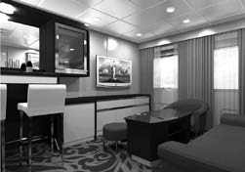
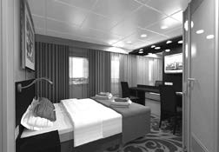
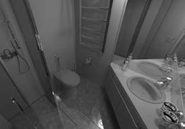
Suite. Living room
Suite. Bedroom
Bathroom
St. Petersburg – Moscow (11 days/10 nights)
Season | Triple Lower deck | Twin Middle deck | Twin Boat deck | Single Middle/Boat deck | Deluxe Twin Main/Middle Deck | Deluxe Twin/Double Middle/Boat Deck | Junior Suite Middle Deck  (N. Chernishevsky) | Suite

A | 1400 | 1620 | 1670 | 1770 | 1750 | 1850 | 1900 | 2000
B | 1400 | 1670 | 1720 | 1820 | 1800 | 1950 | 2000 | 2100
C | 1450 | 1800 | 1850 | 1950 | 1930 | 2100 | 2150 | 2250
D | 1450 | 1820 | 1870 | 2000 | 1950 | 2200 | 2250 | 2350
Moscow-Astrakhan and Astrakhan-Moscow (14 days/13 nights)
Season |  | Triple Lower deck | Twin Middle deck | Twin Boat deck | Single Middle/Boat deck | Deluxe Twin Main/Middle Deck | Deluxe Twin/Double Middle/Boat Deck  (MS N.Chernishevsky) | Junior Suite Middle Deck  (N. Chernishevsky) | Suite
A | 1794 |  | 2080 | 2145 | 2275 | 2249 | 2379 | 2444 | 2574
B | 1794 |  | 2145 | 2210 | 2340 | 2314 | 2509 | 2574 | 2704

Prices are quoted in euros per person per cruise

Single occupancy of atwin cabin
DSU/TWSU of Suites and Junior Suites shall be paid in full as per 2 pax Meeting room
Cabin number when booking Correction in visa support letter
+75% supplement
+100% supplement
+100 €/hr on reservation in advance
+ 50 €per person
+ 10 €per change

Additional terms:
- Cruise booking term is a 10 % deposit which is irrevocable.
- Payment transaction should becompleted 70 days before embarkation.
- 1 tourleader per group of minimum 25 pax is free of charge except port and fuel fees as well as excursion programme.
- Children under the age of 2 are free of charge.
- There is a special discount for children from 2 to 12 years old.
- Specific cabin number – 50 € per person.
- Visa support letter CORRECTION – 10 € per change.
- Discounts don’t sum up.
Included services:
- Transfers (airport-motorship \ motorship-airport) for groups of minimum 20 pax. For groups of less than 20 pax transfers can be organized for extra charge.
- Handling the luggage in river ports and on board.
- Guaranteed accommodation according toyour reservation.
- English/French/German/Spanish/Italian speaking board guides. Services of guides speaking other foreign languages can be provided at additional cost .
- Onboard entertainment including Russian language course and Russian songs lessons, live music concerts, dancing music in bars at nights, Captain’s bridge tour, etc.
- Excursion programme detailed in the cruise itinerary (optional tours are available onboard).
- Use of cabin safe.
- Visa support letter. NOTE: In case of cancelling areservation, errors or change of names, apenalty charge of 10 euros will by applied.

Included meals:
Full board: three meals per day (from dinner on the arrival day to break- fast on the departure day):
- Breakfast onboard is buffet style.
Water in pitchers is provided for breakfast, while tea / coffee is served to the table.
Buffet line has cocoa, milk and juice in assortment, as well as numer- ous hot and cold dishes to guest’s choice.
- Lunch onboard is buffet style.
Water in pitchers is provided for breakfast, while tea / coffee is served
to the table.
- Dinner onboard is served according to the menu:
  - Starter;
  - Main course (a choice of 3 dishes –meat, fish or vegetarian);
  - Dessert (a choice of 2 variants or fruit).
Water in pitchers is provided for dinner, while tea / coffee is served to the table. 1 glass of red/white wine or juice is included for each dinner.
NB: During stay in Moscow and St. Petersburg the menu is fixed (no
choice of dishes).
During the navigation days of the cruise a choice of main course/dessert is provided –guests choose dishes for the next day each previous day.
- 1 bottle of still water (0.33 Lper person per day) is provided in cabins.
- There is acoffee station onboard available for guests from 06:00 till breakfast, from 10:00 till 12:00, from 16:00 till 18:00 and from 21:00 till 23:00. Coffee station includes coffee, decaf, hot water, milk, cocoa, packed tea, sugar, sweetener and cookies.
The following events are organized for guests onboard the ship:
- Welcome Bread and Salt Ceremony on the embarkation day.
- Welcome cocktail including 1 glass of champagne or juice per pax.
- Russian Tea Ceremony with tea and Russian pies and Vodka Show with vodka and blini tasting.
- Cocktail party – once per tour – 1 cocktail to choose out of 3 vari- ants per 1 pax.
- Captain’s dinner with upscale menu.
- BBQ outdoors in Mandrogui (instead of lunch onboard, subject to the weather conditions).
- Mulled wine (during cold weather) / ice tea (during hot weather) upon returning to ship after shore excursions.
- Coffee station for early risers.

Not included services:
- Transfers to and from the port of embarkation / disembarkation for groups of ≤ 20 pax (on request and for extra payment).
- Travel insurances.
- Optional excursions (available onboard).
- Gratuities.
- Personal spendings.
- Cabin numbers are provided 7 days before the cruise or at 50 € supplement per person when booking.
Any other drinks and meals canbe purchased additionally and paid at the restaurant or at the bar onboard.

Cancellation policy:
Ifreservationiscancelledmorethan69daysbeforeembarkation,10% of cruise price is charged (non-refundable deposit).
69-60 days before embarkation – 25% of cruise price. 59-50 days before embarkation – 50% of cruise price. 49-31 days before embarkation – 75% of cruise price.
Less than 31 days before embarkation -100% of cruise price.

